第1章：class文件结构

第1章：class文件结构 1

1 01-概述 2

1.1 字节码文件的跨平台性 2

1.2 Java的前端编译器 3

1.3 透过字节码指令看代码细节 4

2 02-虚拟机的基石：Class文件 5

3 03-Class文件结构 6

3.1 01-魔数：Class文件的标志 9

3.2 02-Class文件版本号 10

3.3 03-常量池：存放所有常量 11

3.3.1 1-常量池计数器 11

3.3.2 2-常量池表 12

2.1 字面量和符号引用 12

2.2 常量类型和结构 13

3.4 04-访问标识 16

3.5 05-类索引、父类索引、接口索引集合 17

3.6 06-字段表集合 18

3.6.1 1-字段计数器 18

3.6.2 2-字段表 18

3.7 07-方法表集合 20

3.7.1 1-方法计数器 20

3.7.2 2-方法表 21

3.8 08-属性表集合 21

3.8.1 1-属性计数器 21

3.8.2 2-属性表 22

3.9 小结 26

4 04-使用javap指令解析Class文件 27

4.1 1-解析字节码的作用 27

4.2 2-javac -g操作 27

4.3 3-javap的用法 28

4.4 4-使用举例 29

4.5 5-总结 41

1. 01-概述
   1. 字节码文件的跨平台性

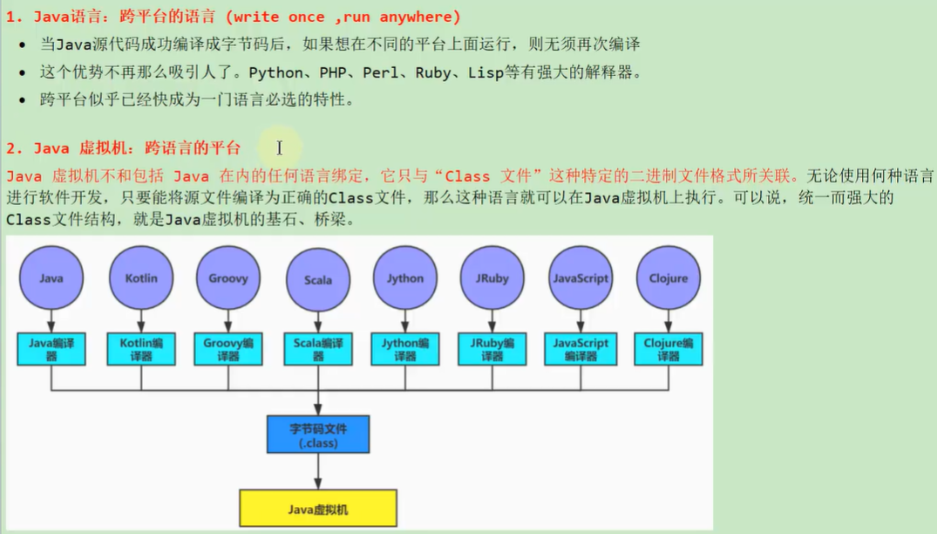

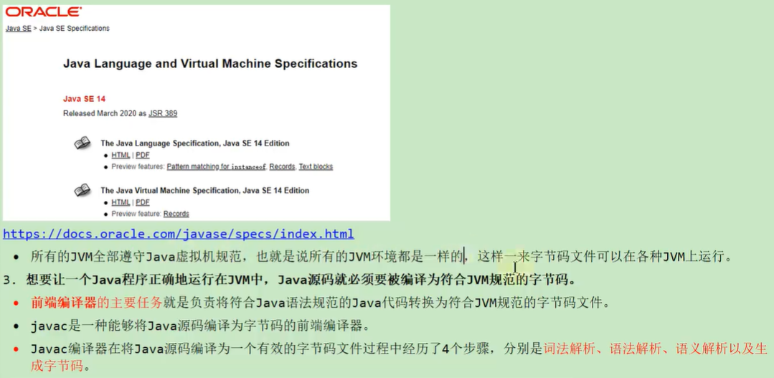

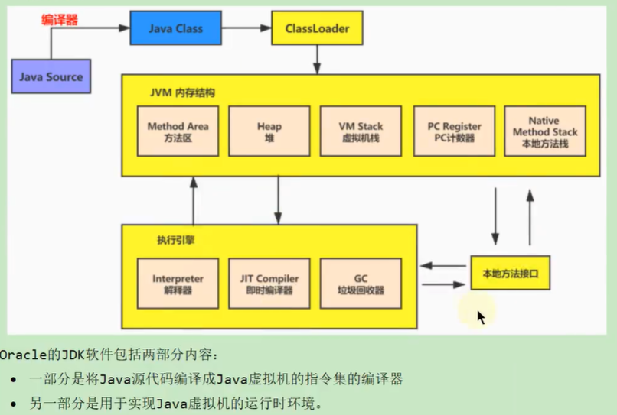

* 1. Java的前端编译器

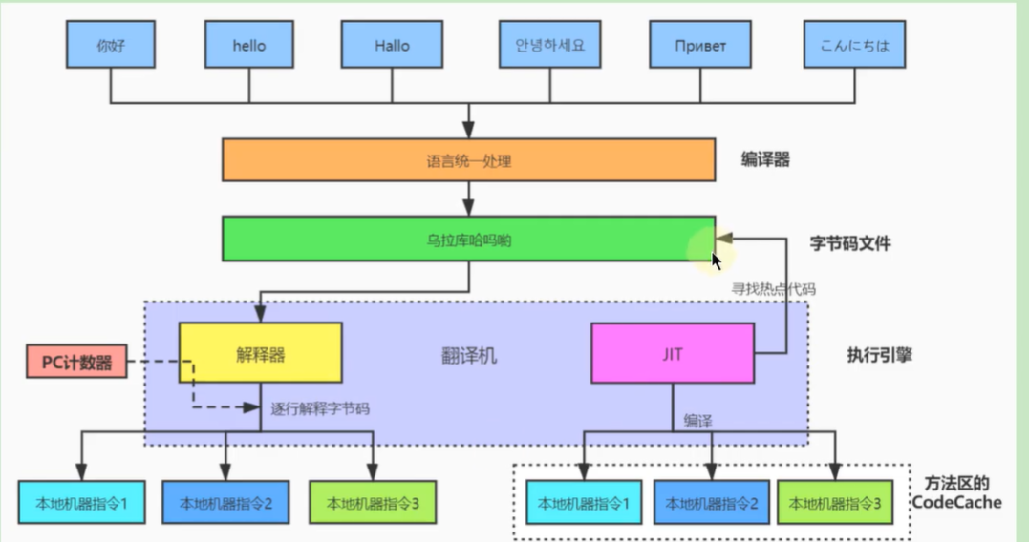

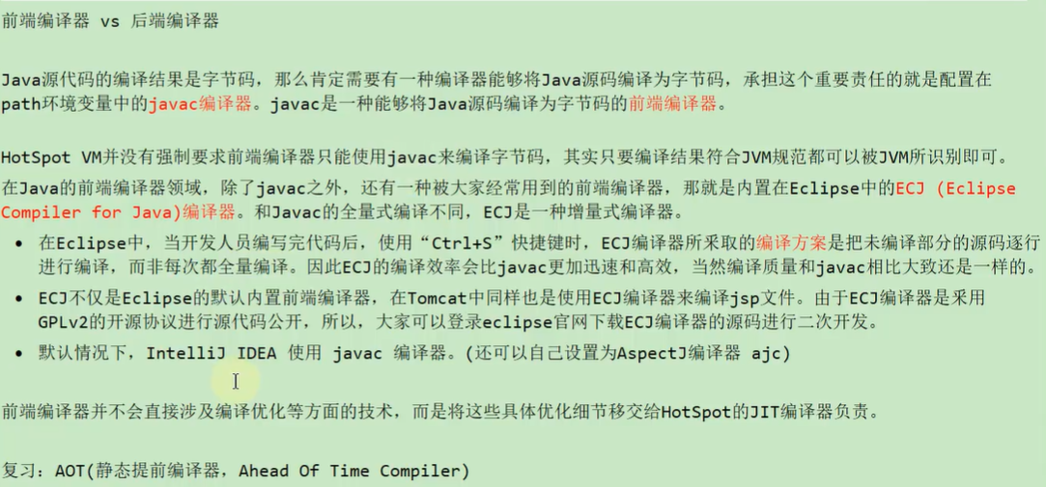

* 1. 透过字节码指令看代码细节

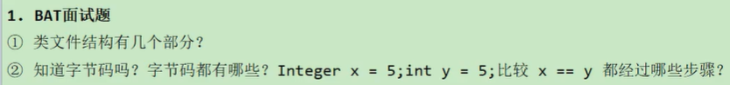

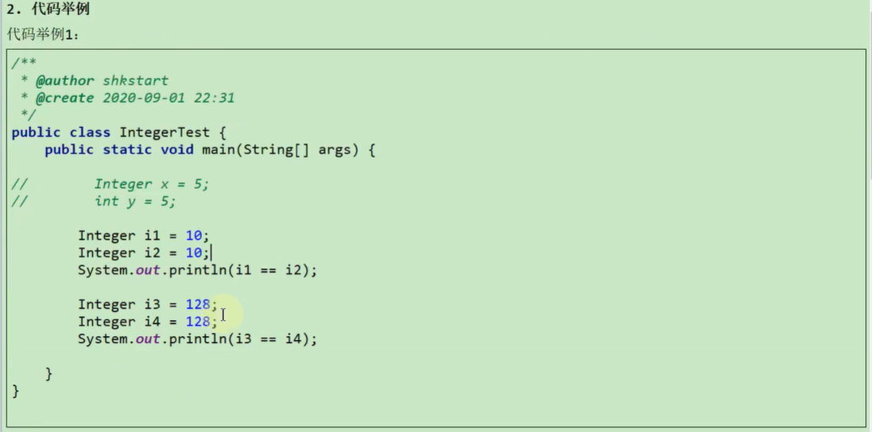

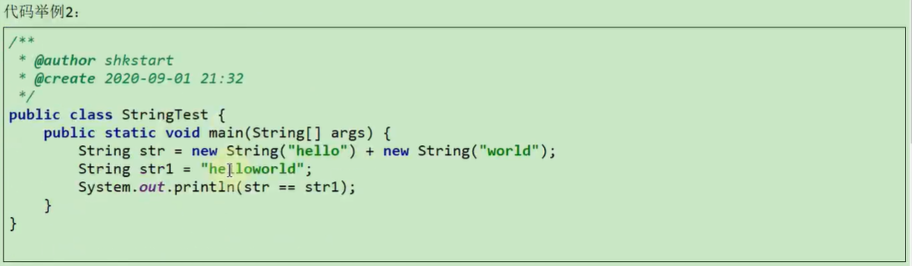

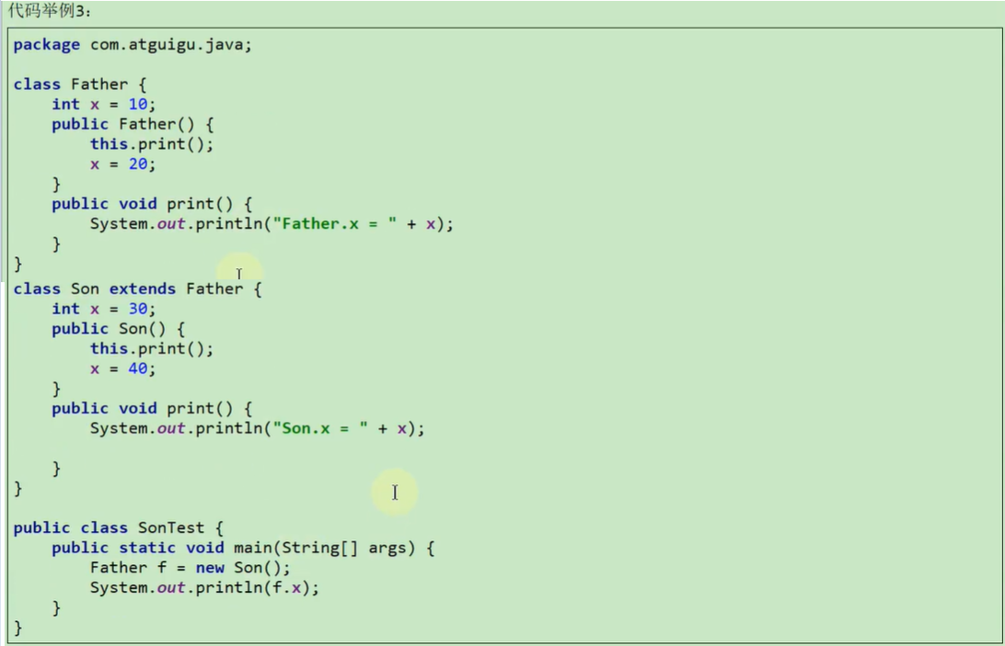

1. 02-虚拟机的基石：Class文件

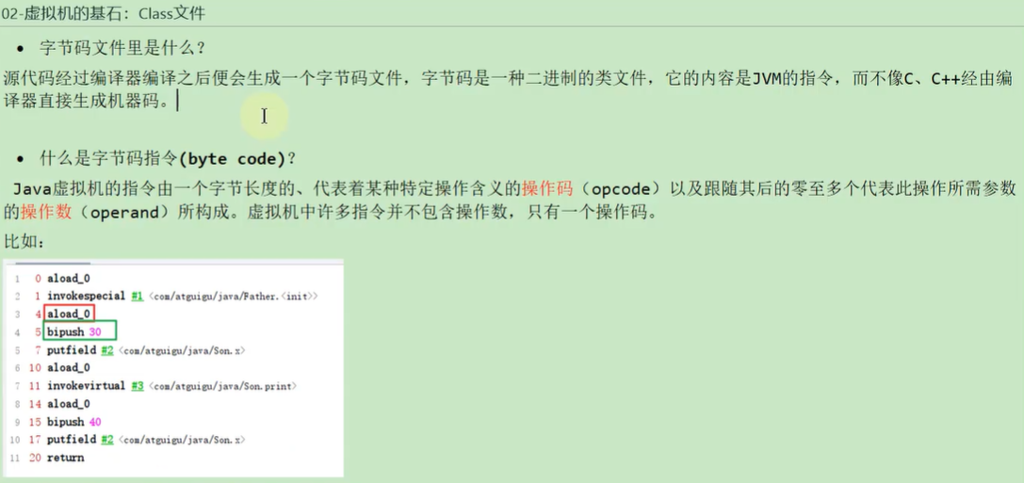

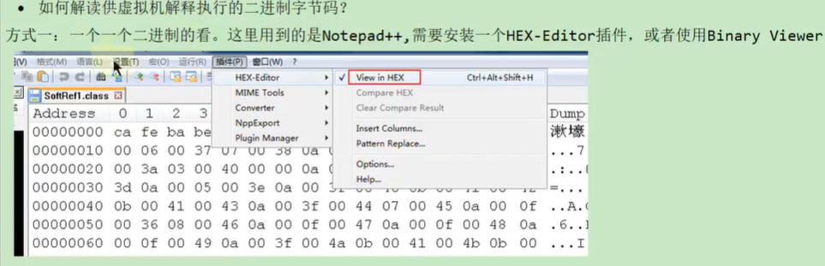

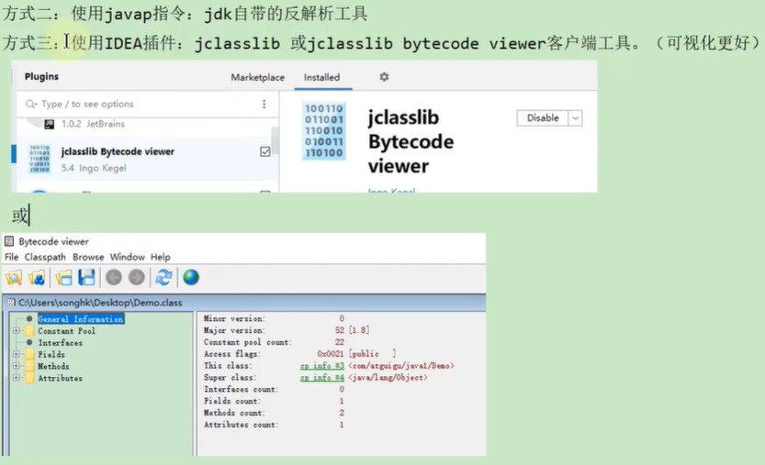

1. 03-Class文件结构

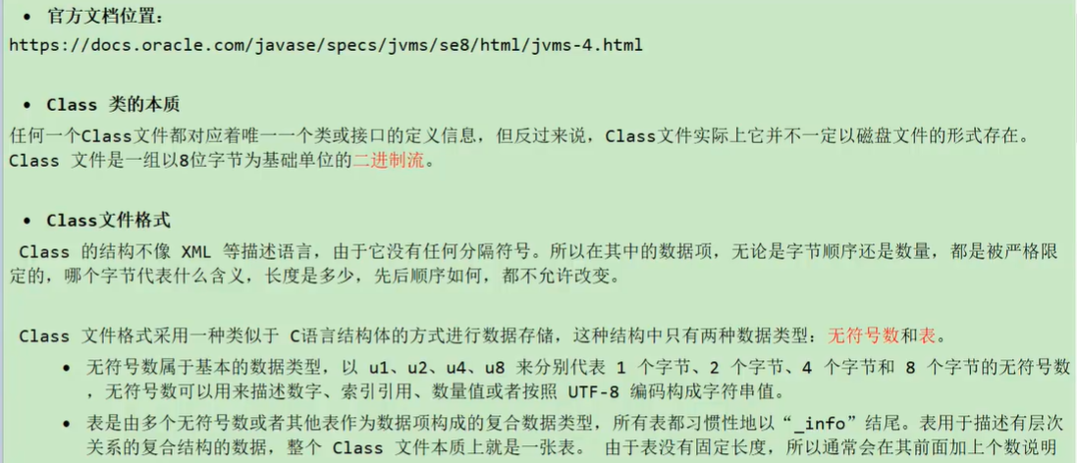

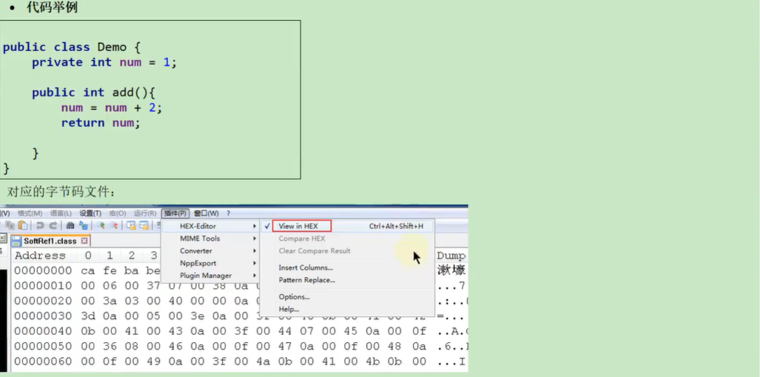

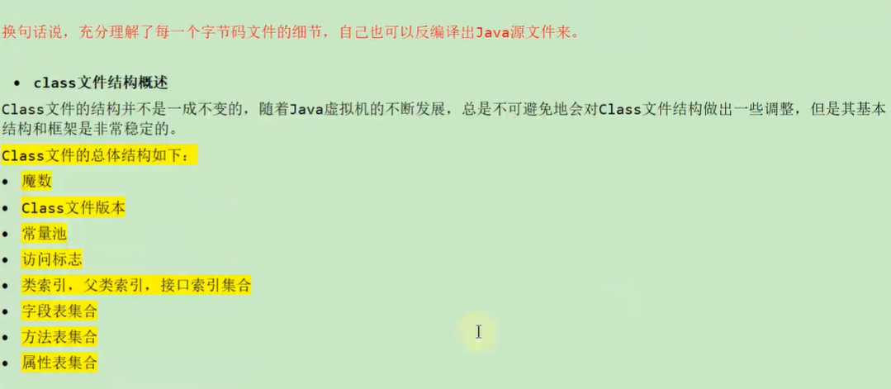

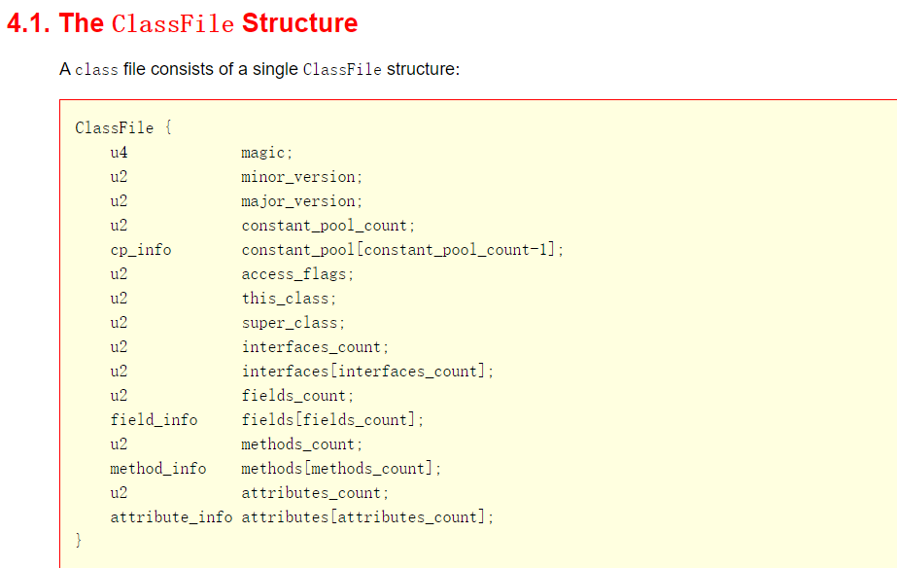

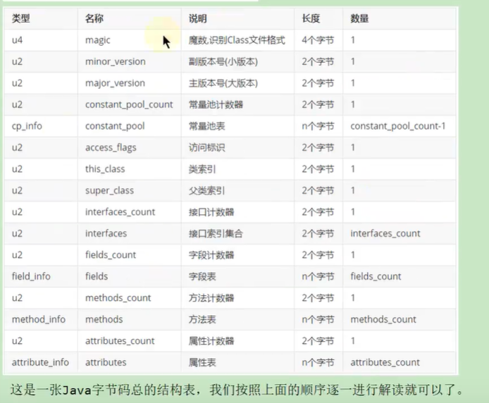



* 1. 01-魔数：Class文件的标志

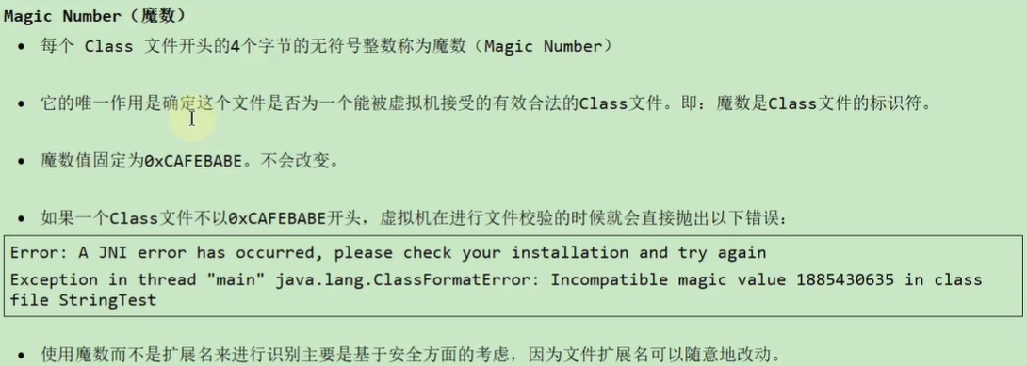

* 1. 02-Class文件版本号

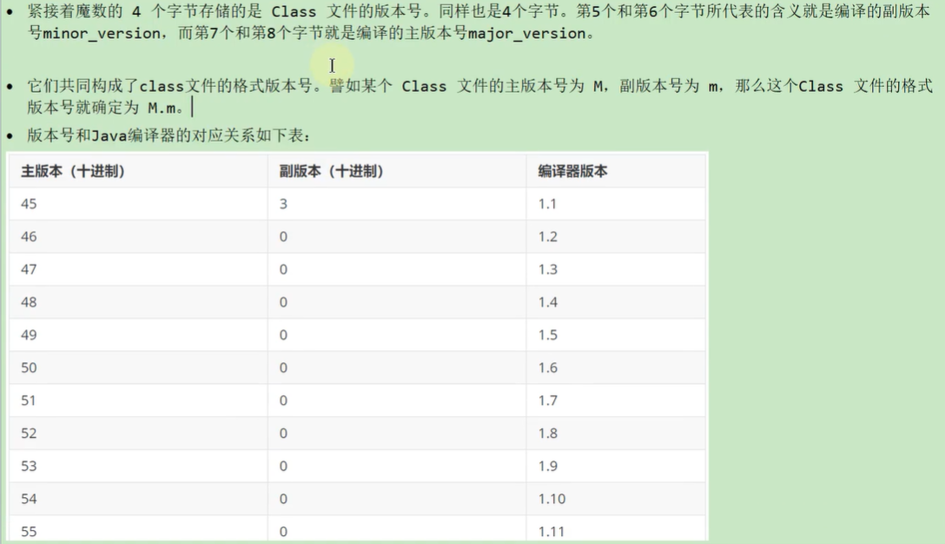

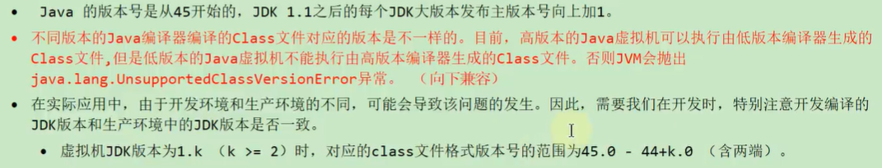

* 1. 03-常量池：存放所有常量

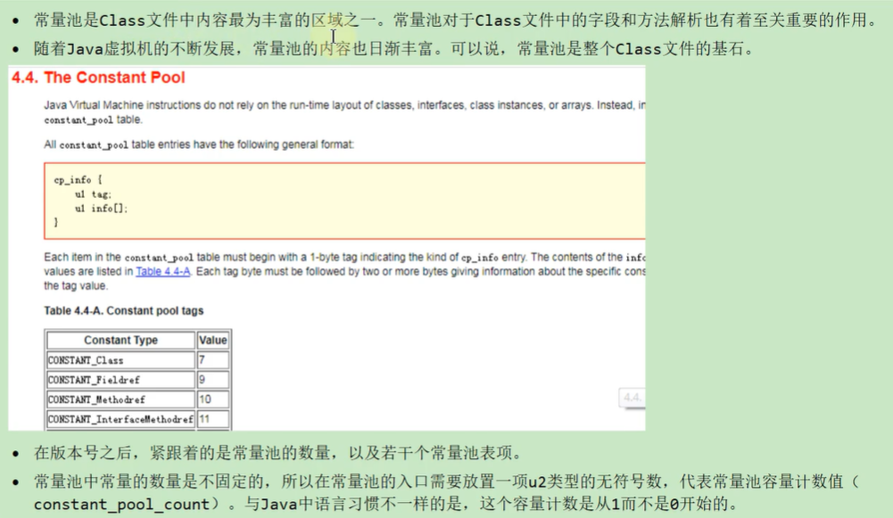

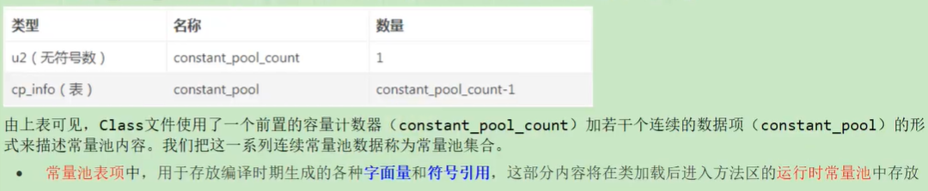

* + 1. 1-常量池计数器

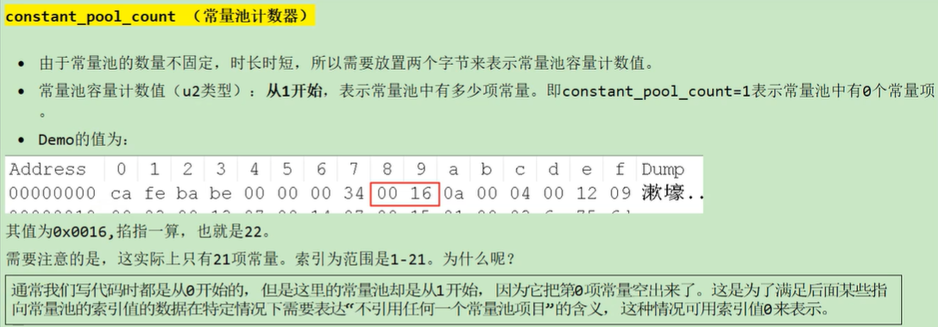

* + 1. 2-常量池表

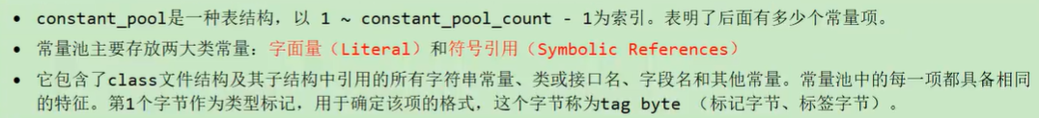

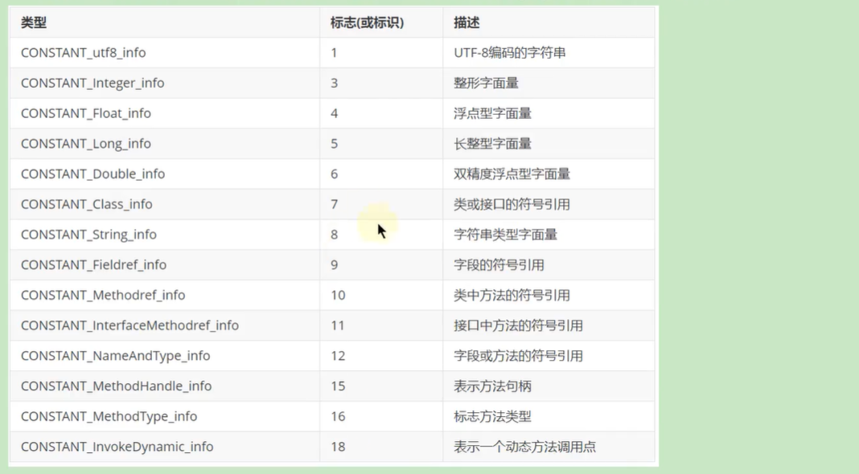

2.1 字面量和符号引用

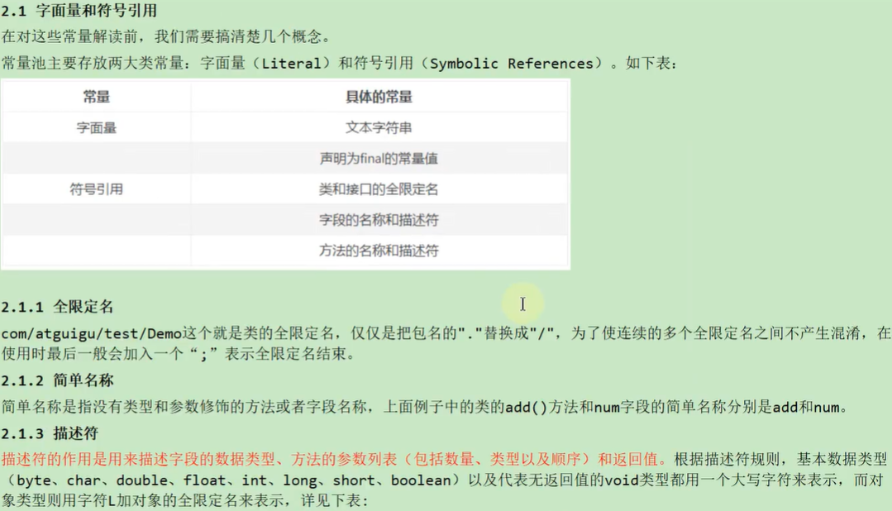

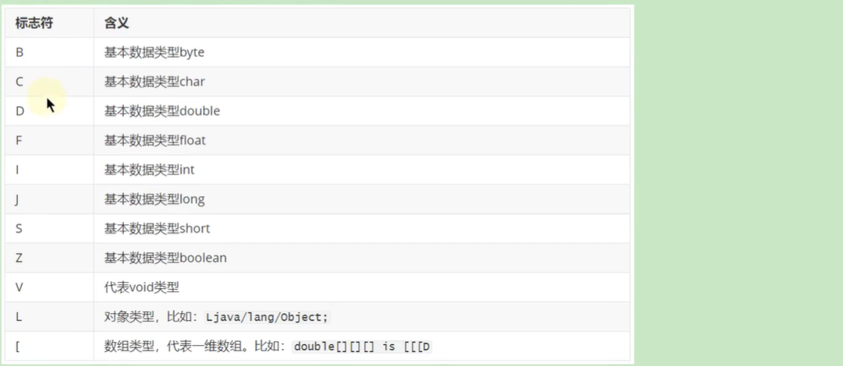

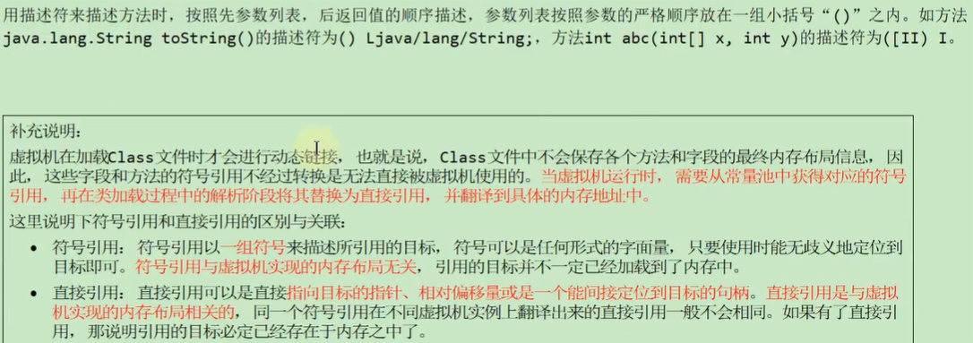

2.2 常量类型和结构



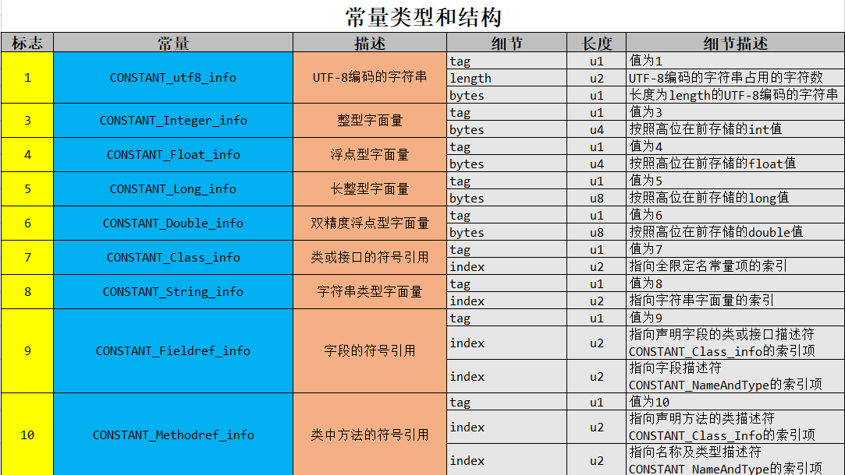

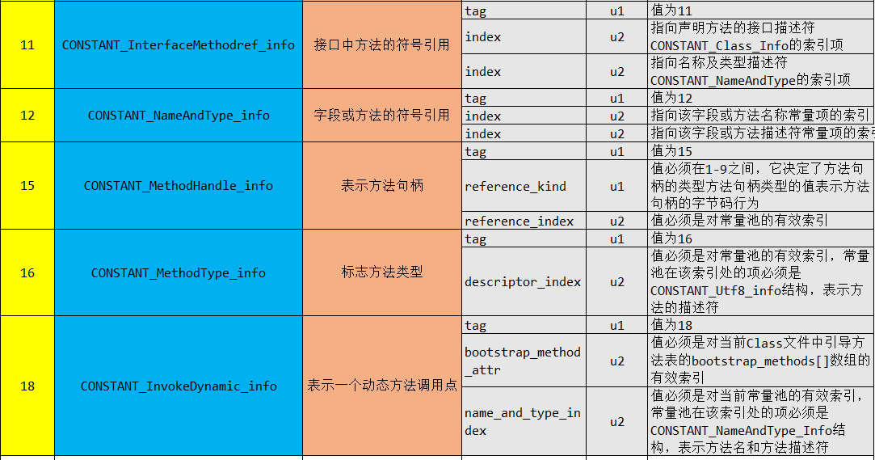

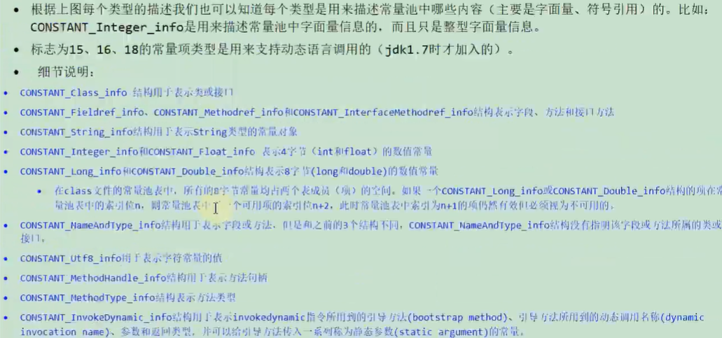

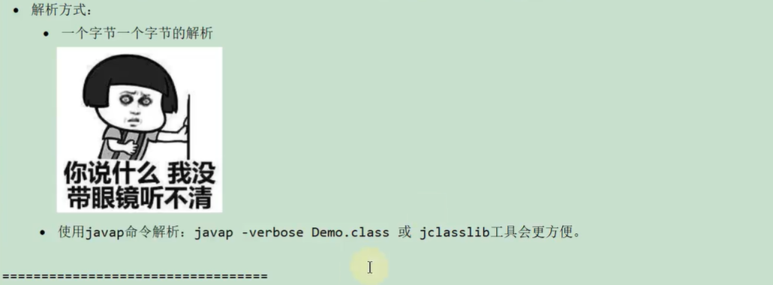

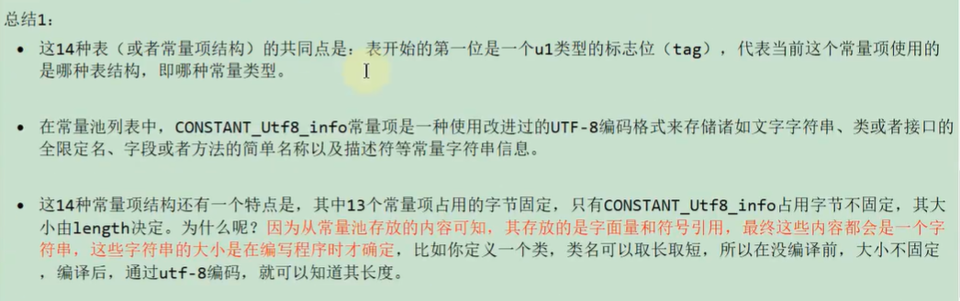

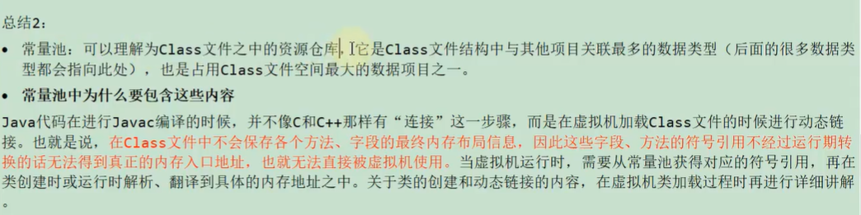

* 1. 04-访问标识

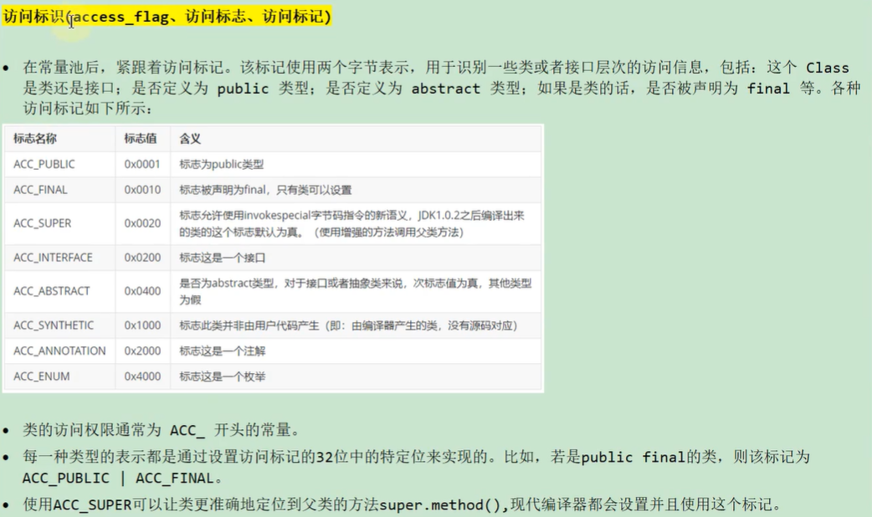

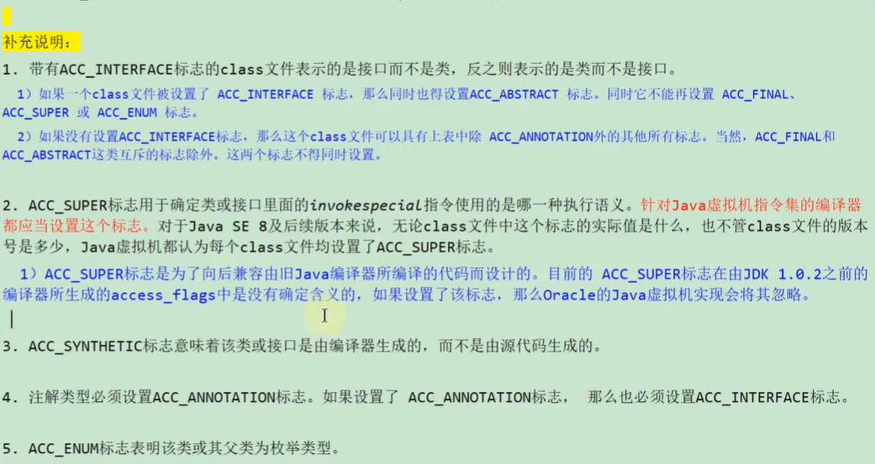

* 1. 05-类索引、父类索引、接口索引集合

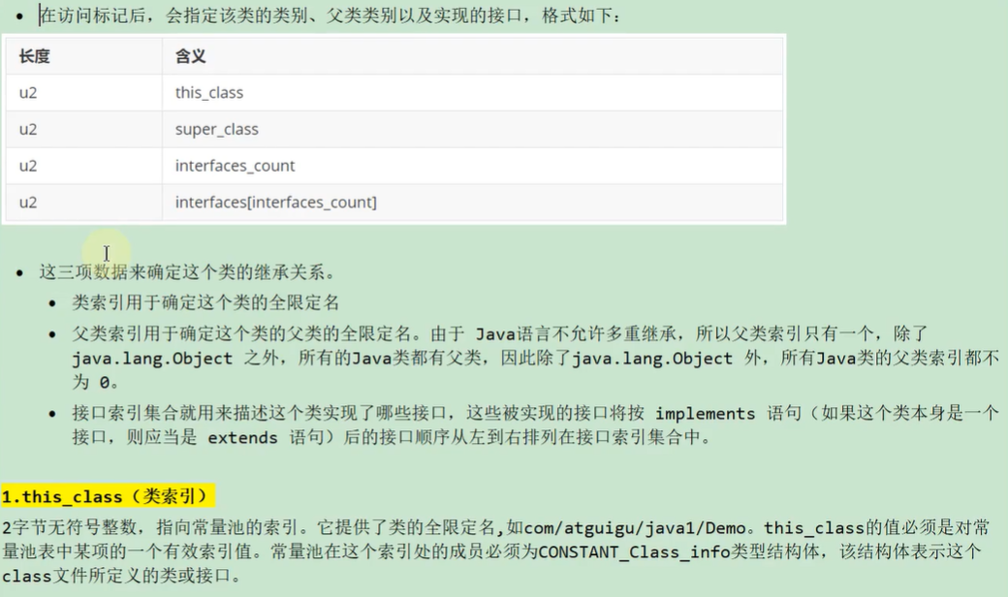

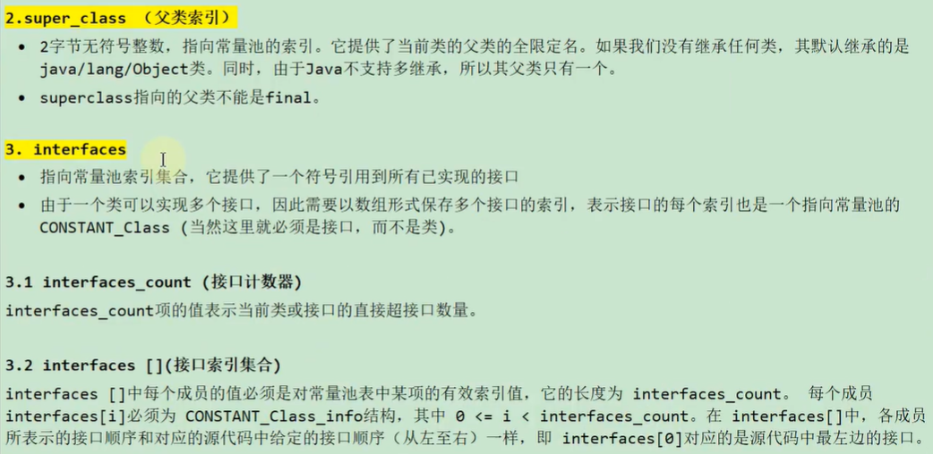

* 1. 06-字段表集合

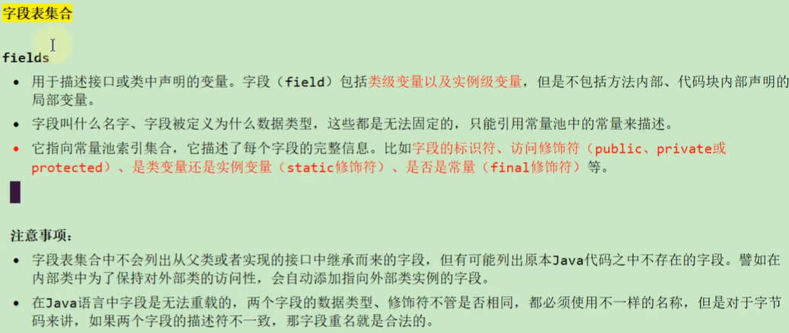

* + 1. 1-字段计数器

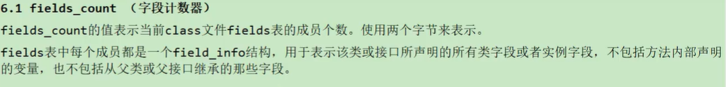

* + 1. 2-字段表

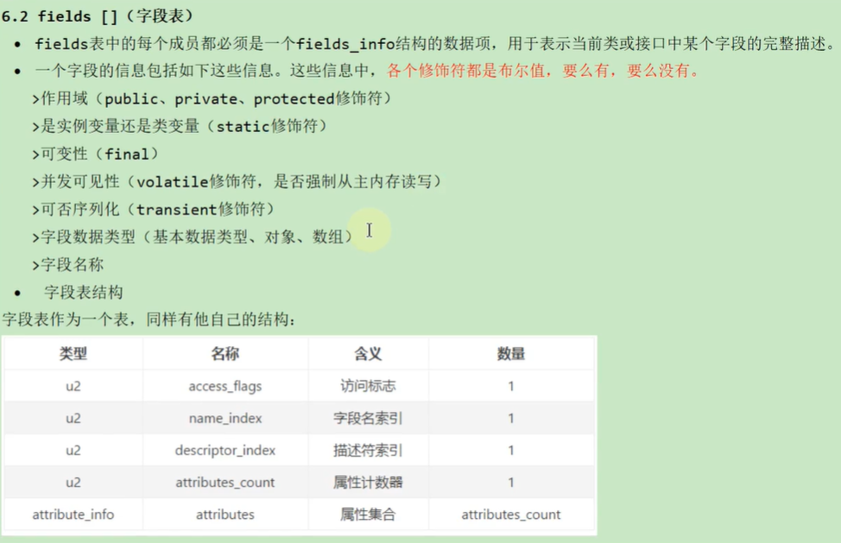

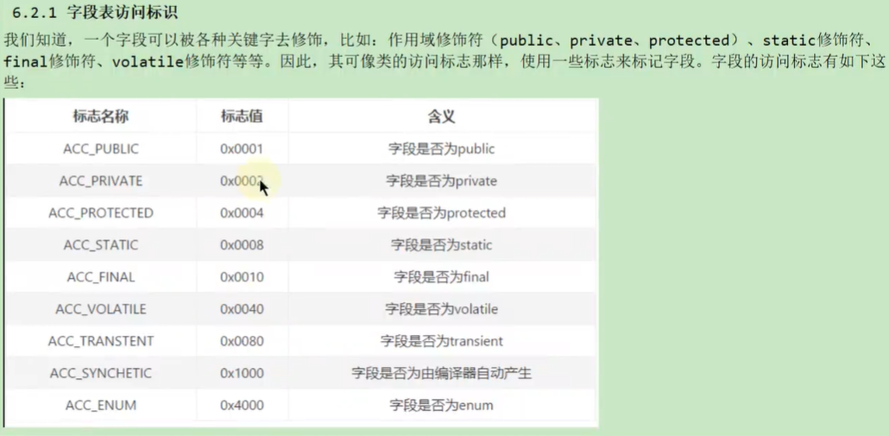



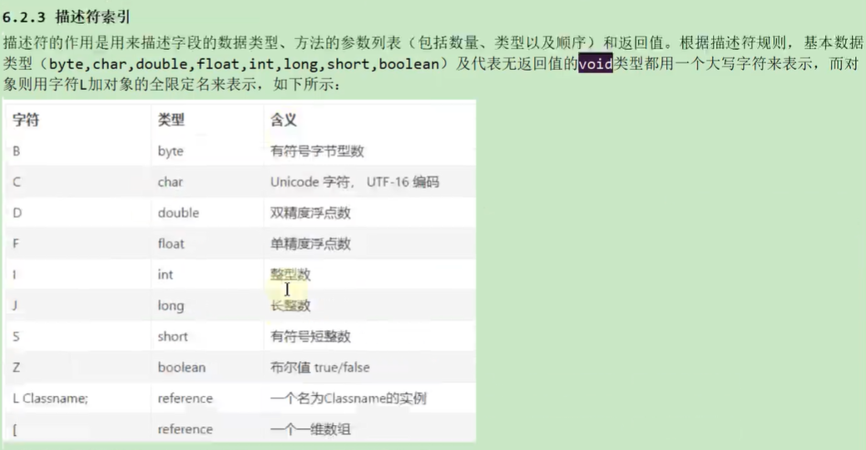

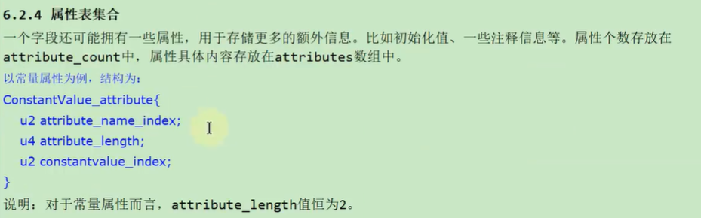

根据上面的例子，我们来实际分析一下，如下图：

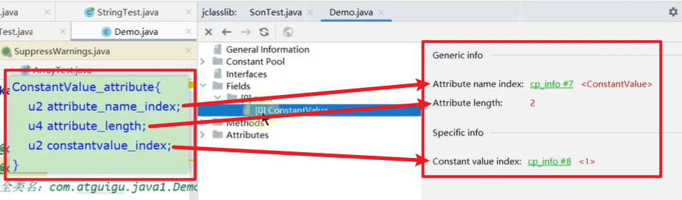

* 1. 07-方法表集合

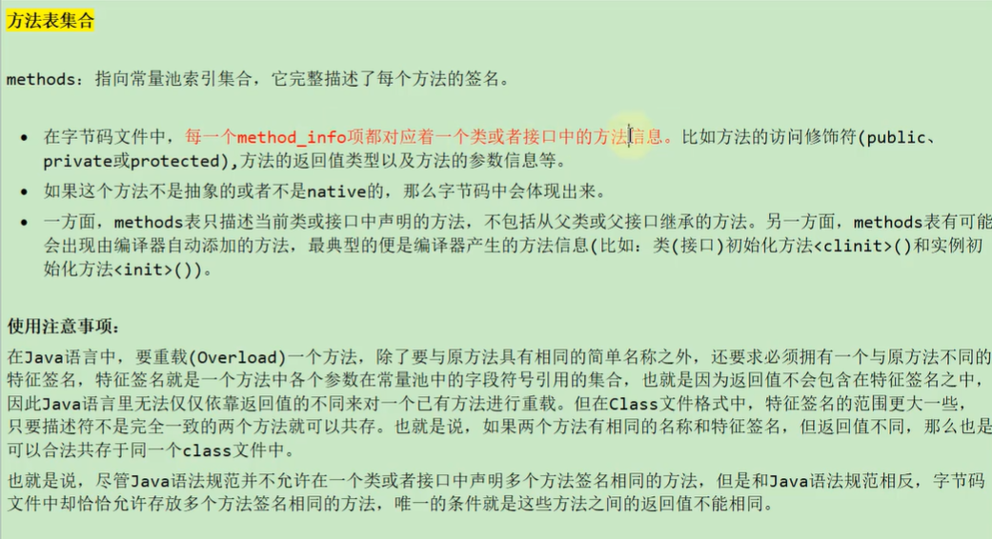

* + 1. 1-方法计数器

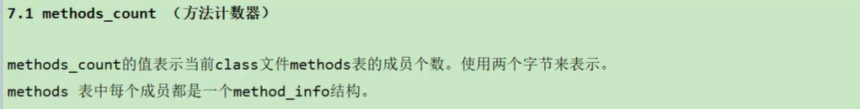

* + 1. 2-方法表

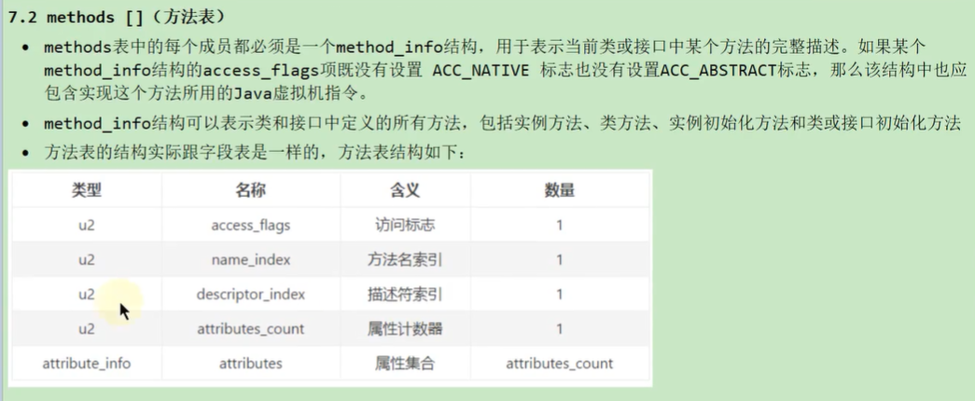

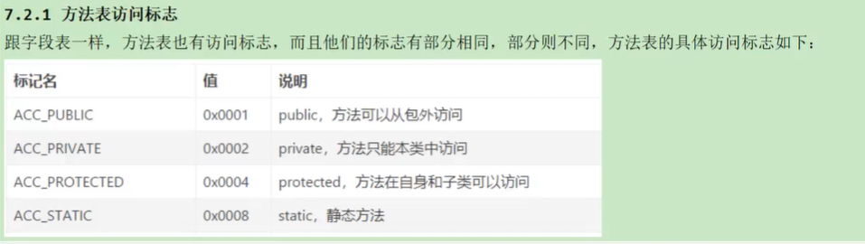

* 1. 08-属性表集合

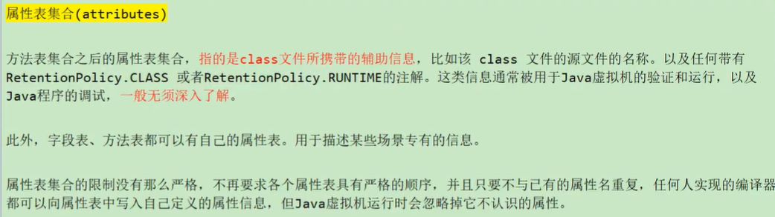

* + 1. 1-属性计数器



* + 1. 2-属性表

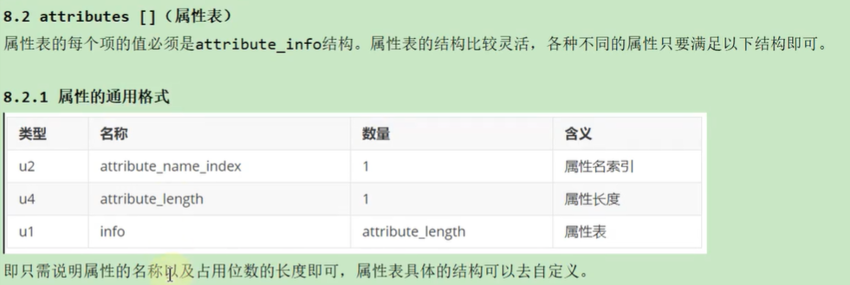

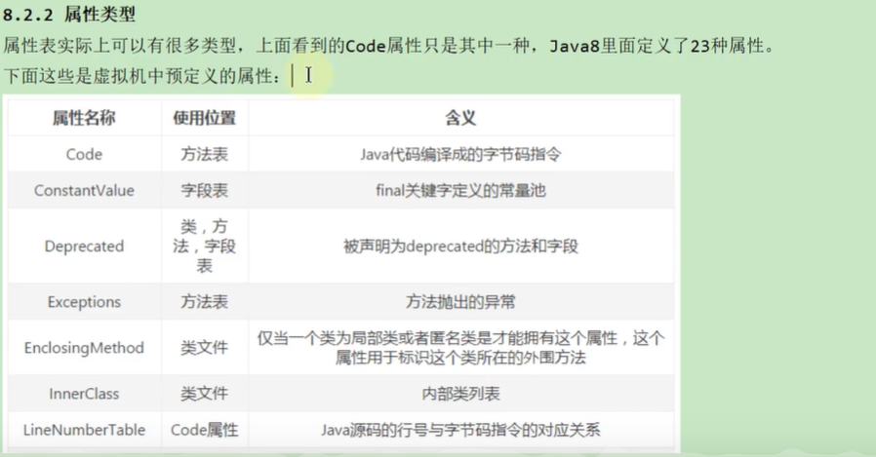

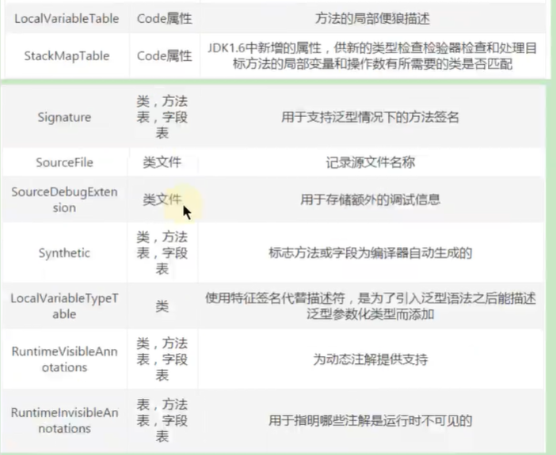

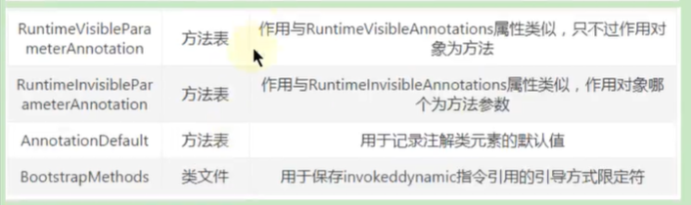

或者（查看官网）

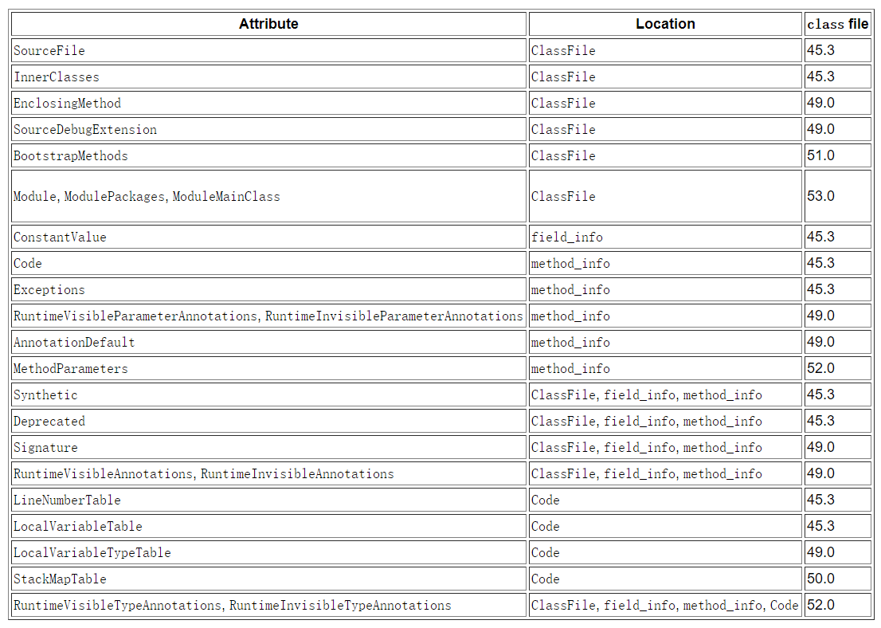

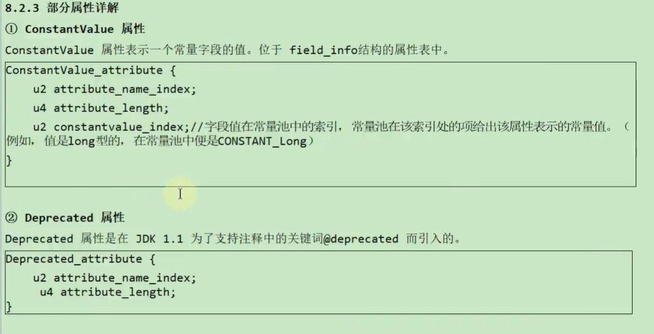

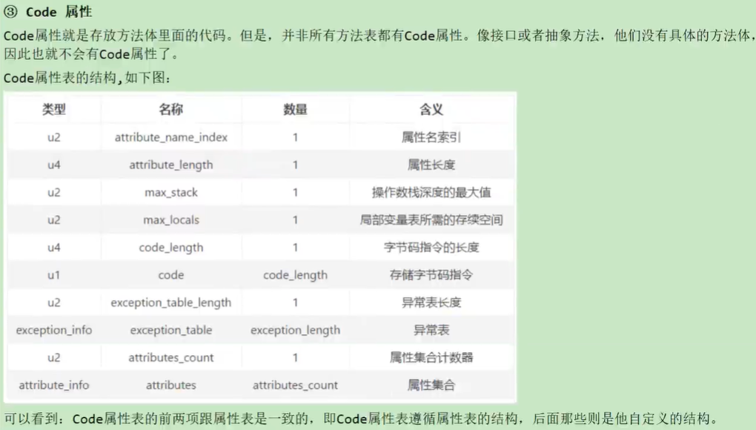

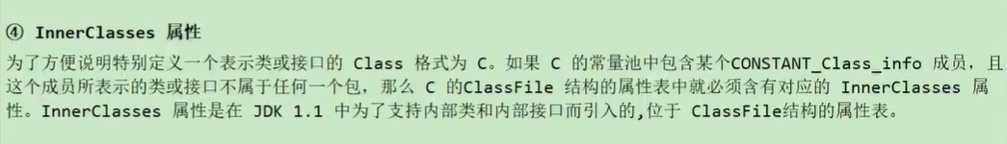

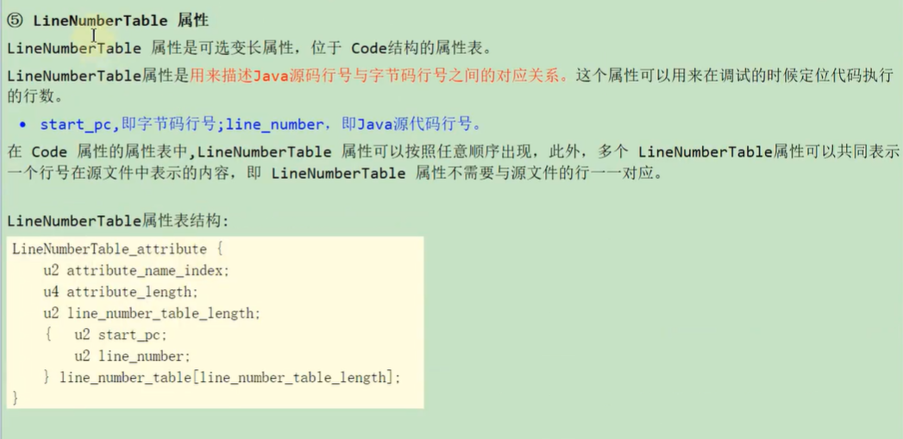

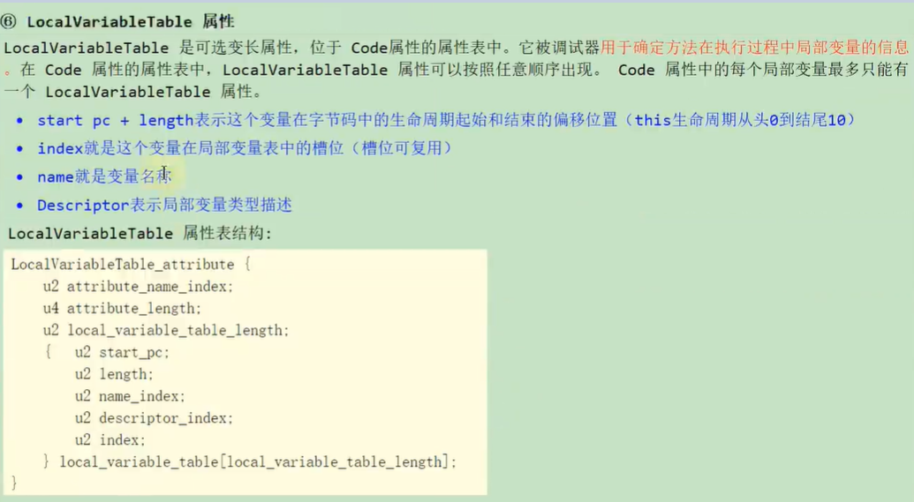

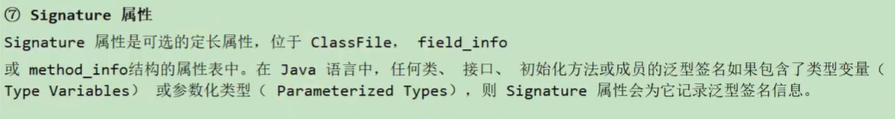

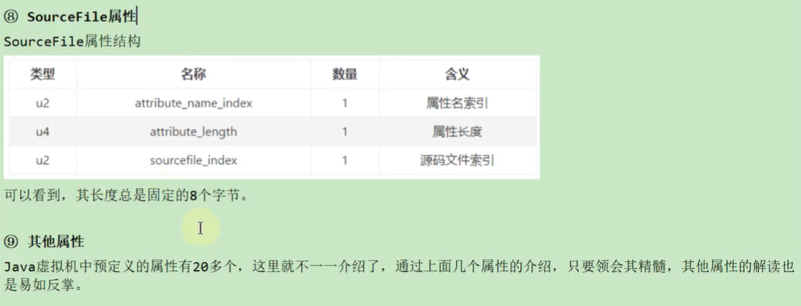

* 1. 小结

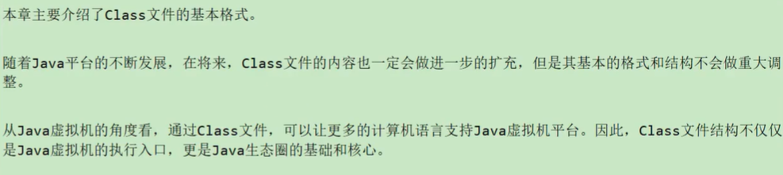

1. 04-使用javap指令解析Class文件

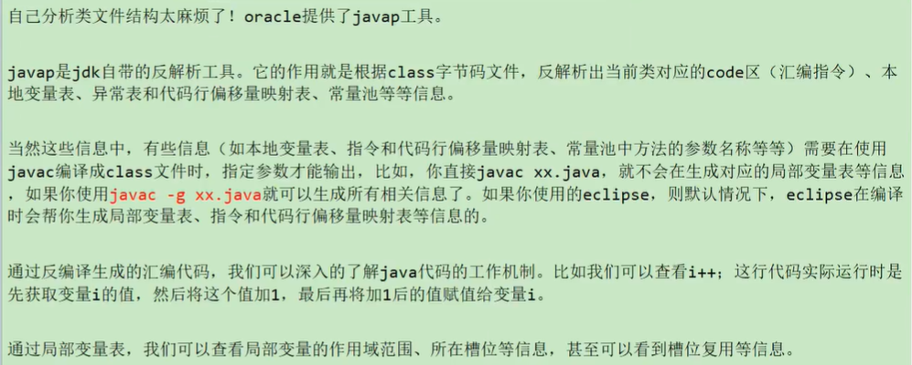

* 1. 1-解析字节码的作用

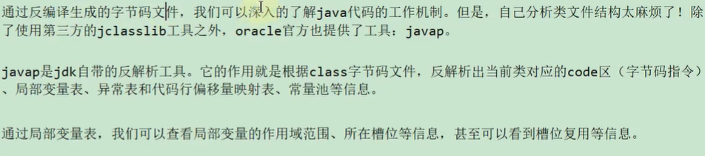

* 1. 2-javac -g操作

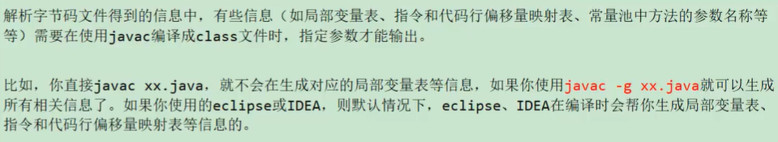

* 1. 3-javap的用法

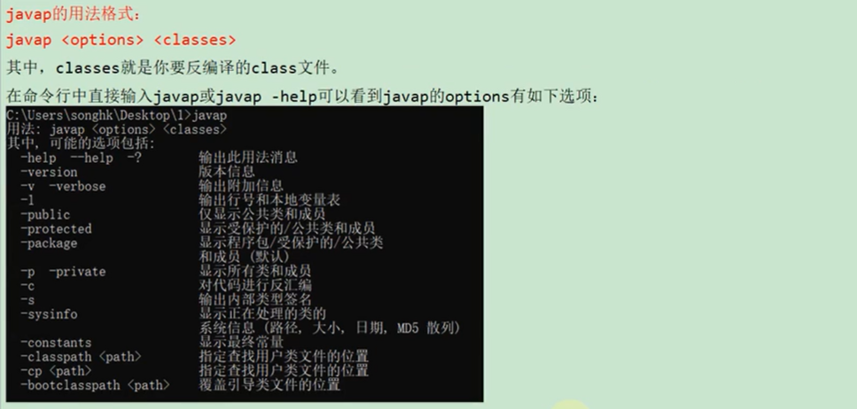

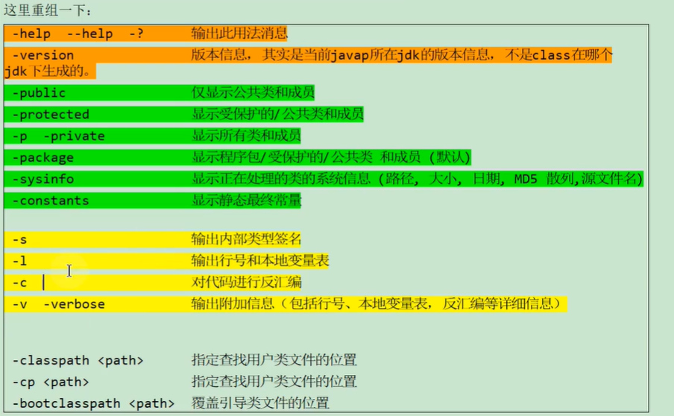

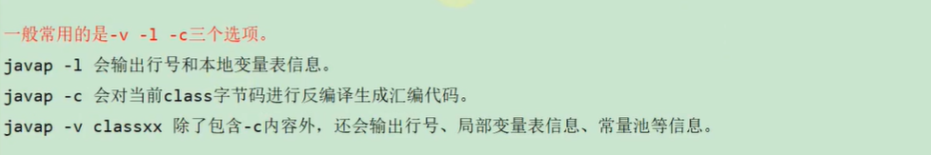

注意：①-v相当于-c -l ②-v也不会输出私有的字段、方法等信息，所以如果想输出私有的信息，那需要在-v后面加上-p才行

* 1. 4-使用举例

**1、代码：**

public class JavapTest {  
 private int num;  
 boolean flag;  
 protected char gender;  
 public String info;  
  
 public static final int *COUNTS* = 1;  
 static {  
 String url = "www.atguigu.com";  
 }  
 {  
 info = "java";  
 }  
 public JavapTest() {  
  
 }  
 private JavapTest(boolean falg) {  
 this.flag = flag;  
 }  
 private void methodPrivate() {  
  
 }  
 int getNum(int i) {  
 return num + i;  
 }  
 protected char showGender() {  
 return gender;  
 }  
 public void showInfo() {  
 int i = 100;  
 System.*out*.println(info + i);  
 }  
}

**2、字节码文件分析：**

Classfile /C:/Users/mingming/Desktop/JavapTest.class // 字节码文件所属的路径

Last modified 2021-2-24; size 1393 bytes // 最后修改时间，字节码文件的大小

MD5 checksum 2c764244fa3a95bfb346c9e416a7a3f6 // MD5散列值

Compiled from "JavapTest.java" // 源文件的名称

public class io.renren.JavapTest

minor version: 0 // 副版本

major version: 52 // 主版本

flags: ACC_PUBLIC, ACC_SUPER // 访问标识

**\*\*\*\*\*\*\*\*\*\*\*\*\*\*\*\*\*\*\*\*\*\*\*\*\*\*\* 常量池\*\*\*\*\*\*\*\*\*\*\*\*\*\*\*\*\*\*\*\*\*\*\*\*\*\*\*\*\*\*\*\***

Constant pool:

#1 = Methodref #16.#48 // java/lang/Object."<init>":()V

#2 = String #49 // java

#3 = Fieldref #15.#50 // io/renren/JavapTest.info:Ljava/lang/String;

#4 = Fieldref #15.#51 // io/renren/JavapTest.flag:Z

#5 = Fieldref #15.#52 // io/renren/JavapTest.num:I

#6 = Fieldref #15.#53 // io/renren/JavapTest.gender:C

#7 = Fieldref #54.#55 // java/lang/System.out:Ljava/io/PrintStream;

#8 = Class #56 // java/lang/StringBuilder

#9 = Methodref #8.#48 // java/lang/StringBuilder."<init>":()V

#10 = Methodref #8.#57 // java/lang/StringBuilder.append:(Ljava/lang/String;)Ljava/lang/StringBuilder;

#11 = Methodref #8.#58 // java/lang/StringBuilder.append:(I)Ljava/lang/StringBuilder;

#12 = Methodref #8.#59 // java/lang/StringBuilder.toString:()Ljava/lang/String;

#13 = Methodref #60.#61 // java/io/PrintStream.println:(Ljava/lang/String;)V

#14 = String #62 // www.atguigu.com

#15 = Class #63 // io/renren/JavapTest

#16 = Class #64 // java/lang/Object

#17 = Utf8 num

#18 = Utf8 I

#19 = Utf8 flag

#20 = Utf8 Z

#21 = Utf8 gender

#22 = Utf8 C

#23 = Utf8 info

#24 = Utf8 Ljava/lang/String;

#25 = Utf8 COUNTS

#26 = Utf8 ConstantValue

#27 = Integer 1

#28 = Utf8 <init>

#29 = Utf8 ()V

#30 = Utf8 Code

#31 = Utf8 LineNumberTable

#32 = Utf8 LocalVariableTable

#33 = Utf8 this

#34 = Utf8 Lio/renren/JavapTest;

#35 = Utf8 (Z)V

#36 = Utf8 falg

#37 = Utf8 MethodParameters

#38 = Utf8 methodPrivate

#39 = Utf8 getNum

#40 = Utf8 (I)I

#41 = Utf8 i

#42 = Utf8 showGender

#43 = Utf8 ()C

#44 = Utf8 showInfo

#45 = Utf8 <clinit>

#46 = Utf8 SourceFile

#47 = Utf8 JavapTest.java

#48 = NameAndType #28:#29 // "<init>":()V

#49 = Utf8 java

#50 = NameAndType #23:#24 // info:Ljava/lang/String;

#51 = NameAndType #19:#20 // flag:Z

#52 = NameAndType #17:#18 // num:I

#53 = NameAndType #21:#22 // gender:C

#54 = Class #65 // java/lang/System

#55 = NameAndType #66:#67 // out:Ljava/io/PrintStream;

#56 = Utf8 java/lang/StringBuilder

#57 = NameAndType #68:#69 // append:(Ljava/lang/String;)Ljava/lang/StringBuilder;

#58 = NameAndType #68:#70 // append:(I)Ljava/lang/StringBuilder;

#59 = NameAndType #71:#72 // toString:()Ljava/lang/String;

#60 = Class #73 // java/io/PrintStream

#61 = NameAndType #74:#75 // println:(Ljava/lang/String;)V

#62 = Utf8 www.atguigu.com

#63 = Utf8 io/renren/JavapTest

#64 = Utf8 java/lang/Object

#65 = Utf8 java/lang/System

#66 = Utf8 out

#67 = Utf8 Ljava/io/PrintStream;

#68 = Utf8 append

#69 = Utf8 (Ljava/lang/String;)Ljava/lang/StringBuilder;

#70 = Utf8 (I)Ljava/lang/StringBuilder;

#71 = Utf8 toString

#72 = Utf8 ()Ljava/lang/String;

#73 = Utf8 java/io/PrintStream

#74 = Utf8 println

#75 = Utf8 (Ljava/lang/String;)V

**\*\*\*\*\*\*\*\*\*\*\*\*\*\*\*\*\*\*\*\*\*\*\*\*\*\*\*\*\*\*字段表集合的信息\*\*\*\*\*\*\*\*\*\*\*\*\*\*\*\*\*\*\*\*\*\*\*\*\*\*\*\*\*\*\*\*\*\*\*\*\*\***

{

private int num; // 字段名

descriptor: I // 字段表集合的信息

flags: ACC_PRIVATE // 字段的访问标识

boolean flag;

descriptor: Z

flags:

protected char gender;

descriptor: C

flags: ACC_PROTECTED

public java.lang.String info;

descriptor: Ljava/lang/String;

flags: ACC_PUBLIC

public static final int COUNTS;

descriptor: I

flags: ACC_PUBLIC, ACC_STATIC, ACC_FINAL

ConstantValue: int 1 // 常量字段的属性：ConstantValue

**\*\*\*\*\*\*\*\*\*\*\*\*\*\*\*\*\*\*\*\*\*\*\*\*\*\*\*\*\*\*方法表集合的信息\*\*\*\*\*\*\*\*\*\*\*\*\*\*\*\*\*\*\*\*\*\*\*\*\*\*\*\*\*\*\*\*\*\*\*\*\*\***

public io.renren.JavapTest(); // 无参构造器方法信息

descriptor: ()V

flags: ACC_PUBLIC

Code:

stack=2, locals=1, args_size=1

0: aload_0

1: invokespecial #1 // Method java/lang/Object."<init>":()V

4: aload_0

5: ldc #2 // String java

7: putfield #3 // Field info:Ljava/lang/String;

10: return

LineNumberTable:

line 16: 0

line 14: 4

line 18: 10

LocalVariableTable:

Start Length Slot Name Signature

0 11 0 this Lio/renren/JavapTest;

private io.renren.JavapTest(boolean); // 单个参数构造器方法信息

descriptor: (Z)V

flags: ACC_PRIVATE

Code:

stack=2, locals=2, args_size=2

0: aload_0

1: invokespecial #1 // Method java/lang/Object."<init>":()V

4: aload_0

5: ldc #2 // String java

7: putfield #3 // Field info:Ljava/lang/String;

10: aload_0

11: aload_0

12: getfield #4 // Field flag:Z

15: putfield #4 // Field flag:Z

18: return

LineNumberTable:

line 19: 0

line 14: 4

line 20: 10

line 21: 18

LocalVariableTable:

Start Length Slot Name Signature

0 19 0 this Lio/renren/JavapTest;

0 19 1 falg Z

MethodParameters:

Name Flags

falg

private void methodPrivate();

descriptor: ()V

flags: ACC_PRIVATE

Code:

stack=0, locals=1, args_size=1

0: return

LineNumberTable:

line 24: 0

LocalVariableTable:

Start Length Slot Name Signature

0 1 0 this Lio/renren/JavapTest;

int getNum(int);

descriptor: (I)I

flags:

Code:

stack=2, locals=2, args_size=2

0: aload_0

1: getfield #5 // Field num:I

4: iload_1

5: iadd

6: ireturn

LineNumberTable:

line 26: 0

LocalVariableTable:

Start Length Slot Name Signature

0 7 0 this Lio/renren/JavapTest;

0 7 1 i I

MethodParameters:

Name Flags

i

protected char showGender();

descriptor: ()C

flags: ACC_PROTECTED

Code:

stack=1, locals=1, args_size=1

0: aload_0

1: getfield #6 // Field gender:C

4: ireturn

LineNumberTable:

line 29: 0

LocalVariableTable:

Start Length Slot Name Signature

0 5 0 this Lio/renren/JavapTest;

public void showInfo();

descriptor: ()V // 方法的描述符：方法的形参列表、返回值类型

flags: ACC_PUBLIC // 方法的访问标识

Code: // 方法的Code属性

stack=3, locals=2, args_size=1 // stack：操作数栈的最大深度 locals：局部变量表的长度 args_size：方法接受参数的个数

// 偏移量 操作码 操作数

0: bipush 100

2: istore_1

3: getstatic #7 // Field java/lang/System.out:Ljava/io/PrintStream;

6: new #8 // class java/lang/StringBuilder

9: dup

10: invokespecial #9 // Method java/lang/StringBuilder."<init>":()V

13: aload_0

14: getfield #3 // Field info:Ljava/lang/String;

17: invokevirtual #10 // Method java/lang/StringBuilder.append:(Ljava/lang/String;)Ljava/lang/StringBuilder;

20: iload_1

21: invokevirtual #11 // Method java/lang/StringBuilder.append:(I)Ljava/lang/StringBuilder;

24: invokevirtual #12 // Method java/lang/StringBuilder.toString:()Ljava/lang/String;

27: invokevirtual #13 // Method java/io/PrintStream.println:(Ljava/lang/String;)V

30: return

// 行号表：指明字节码指令的偏移量与java源代码中代码的行号的一一对应关系

LineNumberTable:

line 32: 0

line 33: 3

line 34: 30

// 局部变量表：描述内部局部变量的相关信息

LocalVariableTable:

Start Length Slot Name Signature

0 31 0 this Lio/renren/JavapTest;

3 28 1 i I

static {};

descriptor: ()V

flags: ACC_STATIC

Code:

stack=1, locals=1, args_size=0

0: ldc #14 // String www.atguigu.com

2: astore_0

3: return

LineNumberTable:

line 11: 0

line 12: 3

LocalVariableTable:

Start Length Slot Name Signature

}

SourceFile: "JavapTest.java" // 附加属性：指明当前字节码文件对应的源程序文件名

**3、jclasslib展示的内容：**

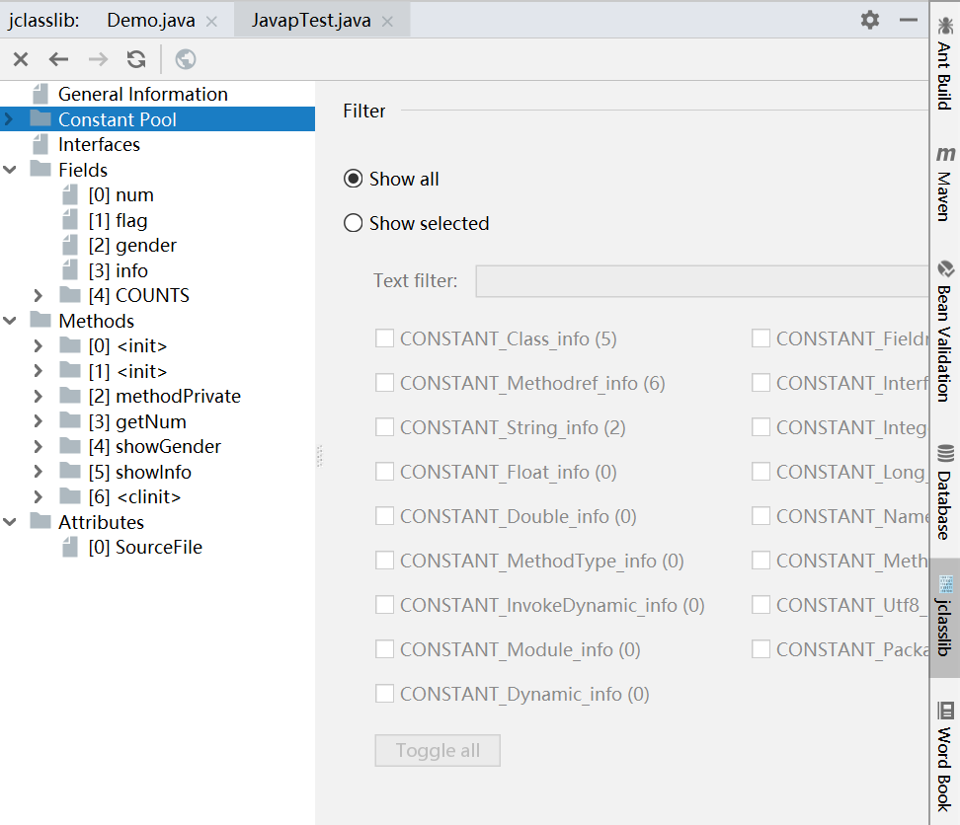

* 1. 5-总结

